CITY GATE HOUSE _ HERBERT SMITH NORTH WEST ENTRANCE

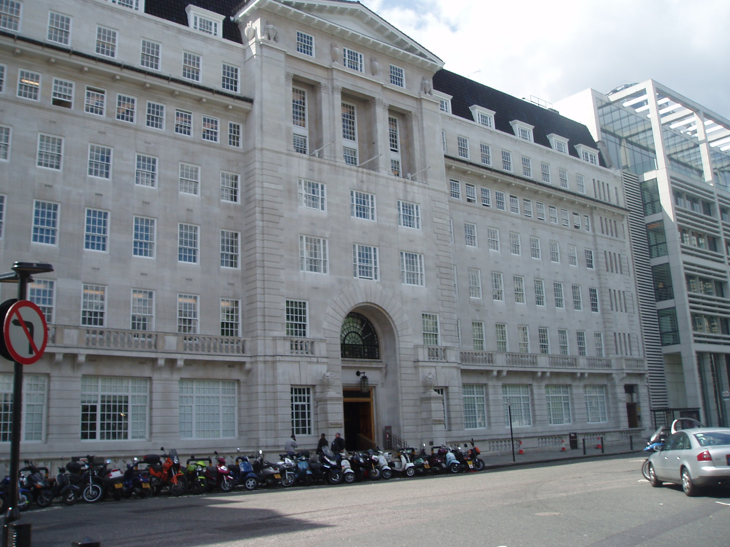

MAP OF CITY GATE HOUSE

Exchange House  Primrose Street  London  EC2A 2HS  T: +44 (0)020 7374 8000  F: +44 (0)020 7374 0888  10 Exchange Square  4th & 5th Floors  City Gate House  39-45 Finsbury Square  London  EC2A 1PX | 