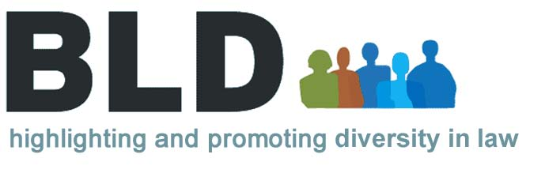

THE EVENT AND EVENT DETAILS

Creating a Positive Impact: A New Year, a New Attitude is a workshop about communicating with clarity, confidence and commitment as your ability to do so is your number one key to success. No matter how capable, intelligent, or driven you are, if you cannot engage with your listener your career is limited.

WHAT YOU WILL LEARN
Attendees will discover the impact of the ABCs of successful communication: Attitude, Behaviour and Confidence. You will explore your personal values and discover how they impact on how you are perceived. While exploring perceptions – yours and others – you’ll learn how to create the impression you want to make.

WHO SHOULD ATTEND?
Anyone who wants to communicate with clarity, confidence, and commitment.

TRAINER’S BIOGRAPHY
For over twenty years Elizabeth Kuhnke has nurtured a steady stream of FTSE 100 companies, professional services, and charities, providing one-to-one and group coaching in key areas relating to public speaking, personal impact, and image projection. Whether international sports stars or CEOs of global corporations, her clients are predominantly individuals working their way up the career ladder or making the transition into public life. Elizabeth’s combination of advanced degrees, a career in the performing arts, expertise in administering psychometric instruments and a passion for personal best are some of the reasons clients turn to her for support.

Elizabeth is often quoted in the media addressing issues concerning confidence, image, voice, body language, and public speaking skills. She is the best-selling author of Body Language for Dummies which is currently published in the USA, UK, Germany, Poland, and Bulgaria.

MATERIALS
Materials will be provided on the day for attendees to take away.

DATE AND VENUE
Date: Thursday 19 January 2010 Time: 6.00pm
Venue: Simmons & Simmons, CityPoint, Ropemaker, London, EC2Y 9SS
How to Get There: Click here to view the Map direction or copy this link onto your browser: http://www.simmons-simmons.com/imgs/offices/New_London.pdf.

BOOKING AND OTHER INFORMATION
This 3-hour training workshop (which includes an hour to practice what you have learned and refreshments) is hosted by the international law firm, Simmons & Simmons and carries 3 CPD points. The event is free to BLD members and costs £60 to non-members. It carries 3 CPD Points.

See online at www.onlinebld.com for further details or email events@onlinebld.com.

